Pro Account
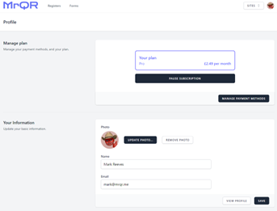
The free user account can be upgraded anytime to the Pro Account at any time.
Pro account subscriptions are paid monthly. See Pricing for details.
With the Pro account users can add and store all their profile information including training and equipment records these can be shared and used to auto populate forms on any MrQR Site.
Profile information can include.
- Image ID
- Full Name
- Date of Birth
- Multiple Telephone Numbers
- Employer
- Employment Status
- National Insurance Number
- Multiple Next of Kin – Names
- Multiple Next of Kin – Contact numbers
- Medical Information
- User Defined Text, Numbers, Email Addresses and Dates
- Multiple Training Records (Expired Training Records will not appear on your shared profile and not available for auto form fill)
- Multiple Equipment Records
- Multiple Addresses

